Autonomous Vehicles
  - Technical and Legal Challenges:
An Overview of the State of the Art in Autonomous Vehicle Technology and Policy

Driverless Cars were suggested in the 1940’s. The original idea relied on a centralized grid, which would direct your car while you enjoyed the ride.
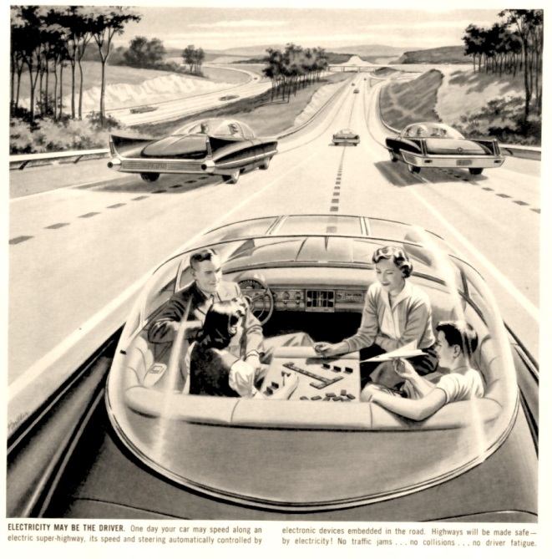
1: Driverless Concept
Modern driverless cars will sense their environment (and other drivers) like a person, and will operate with true autonomy without requiring new infrastructure.
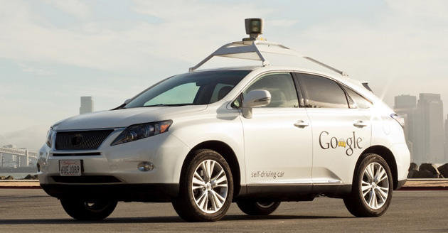
2: Google test car
But integrating autonomous vehicles will require a comprehensive legal framework.

Table of Contents
Technical State of the Art 3
I. Definitions and Background 3
Types of Autonomy 3
Types of Control 4
II. Timeline 5
III. Impact 6
On Individuals 6
On Washington State 6
IV. Technical Challenges 7
Legal Landscape in The United States 7
Current Status in Washington 7
Current Law on Major Issues 8
A. Definitions and Scope 8
B. Authority on Rules and Regulations 9
C. Legislating the Testing Phase 9
D. Licensing and Permitting 9
E. Manual Override and Attentive Driver Issues 9
F. Criminal and Infraction Liability 10
G. Civil Liability 10
H. Other Unique Issues 10
Conclusion on Varying State Approaches 10
Preemption 11
I. Express preemption 11
II. Implied preemption 12
A. Field preemption 12
B. Conflict preemption 13
Legislative Role 14

Technical State of the Art

Definitions and Background
  - What is an autonomous vehicle?
The terms ‘Autonomous Vehicles’, ‘Self-driving Cars’, and ‘Driverless Cars’ tend to be used interchangeably, to mean a vehicle which can navigate between two points safely without human intervention. However, there is a continuum of autonomy. Some (existing) vehicles can take over basic functions, much like cruise control takes over speed-setting, but cannot take any responsive actions. Some hypothesized vehicles will be able to respond to a text message, turn themselves on, and drive (unoccupied) to their owner.

Types of Autonomy

Assistive autonomy
Sometimes also referred to as a “super cruise-control”, assistive autonomy comprises many of the safety features seen in cars already on the road. Forms of assistive autonomy include:
- Cruise control, which automates speed-setting
- Adaptive cruise control, which detects the relative position and speed of a lead vehicle and adjusts the vehicle’s speed to match or to avoid a collision.
- Lane management, which detects the position of the lane lines, or the distance to nearby vehicles, and adjusts steering to keep the vehicle within the lane.

Assistive autonomy systems are beginning to appear on 2014 model years. The BMW™ 3-Series offers an assistive suite called Active Protection:

Active Protection detects the threat of a collision via the front camera or front radar, by all-out braking initiated by the driver or if the vehicle shows strong signs of understeering or oversteering.
…
If a crash was unavoidable, the system applies the vehicle’s brakes automatically and brings it to a standstill, without the driver needing to act. This reduces – or in an ideal case completely rules out– the probability of secondary of follow-on collisions and their consequences.

Comparable autonomy systems have also appeared in Mercedes™ vehicles. The C-Class offers a lane-keeping system, described as:

With Lane Keeping Assist, a special camera watches the markings on the pavement as you drive. If it senses that you're drifting out of your lane, it vibrates the steering wheel. And with either system, advanced active technology can apply the brakes on one side of the vehicle, to help guide you back into your own lane.

Although in theory, and at great personal risk (and liability), one could cross vast distances on the freeway with only assistive features activated; in practice, vehicles with assistive autonomy will require an alert human driver at all times, because the vehicle will be unable to adapt to changing conditions or to find a destination. The prime challenge in designing assistive autonomy systems is to determine when the vehicle needs to act autonomously – for instance, can the vehicle take control away from the driver in order to brake? Can the vehicle adjust its lane position to avoid an imminent collision with debris? And insofar as assigning liability, to what extent is a driver at fault when a collision occurs while the vehicle is partially automated?

Managed autonomy
Vehicles with managed autonomy would function on a combination of stored map data, onboard sensors, and regularly updated instructions from a central server. This is the type of vehicle most often envisaged by the term “driverless cars”, and assumes that the vehicles will require up-to-date mapping information, such as “Google Maps”™ data, which must be continually kept current.

It is a subject of current research to provide these vehicles with the ability to adapt to changing conditions. How does the vehicle respond to an abrupt change like a construction zone, a detour, or debris? And how can we apportion liability for accidents that arise in these situations?

Fully Independent autonomy
Fully independent vehicles that operate without instructions from a server based on updated map data remain in the research prototype stage at this point. Such vehicles would require as-yet unachieved advances in artificial intelligence.

Types of Control

Centralized control
A central grid or server directs the movements of autonomous vehicles. This type of control was the primary mechanism hypothesized in much science fiction and by the earliest proponents of ‘driverless’ technology. Modern thinking on autonomous vehicles would use the concept of a “grid” primarily insofar as a route-planning device, and would rely on a data provider to connect the vehicle with updated maps.

Distributed control
Each autonomous vehicle contains a comprehensive set of sensors with which to navigate its environment, based on centralized mapping data. Technical challenges include: adverse conditions, unpredictable behavior of other vehicles, and the expense of the current generation of sensing equipment. Notably, a number of cost-reduction strategies may eventually return such vehicles to a cost-competitive realm.

Timeline
  - When will autonomous vehicles arrive?
  - 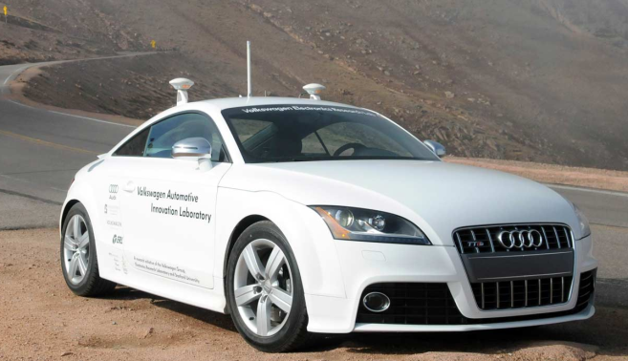
3: Audi Autonomous TTS
Test vehicles operated by Google and others are claimed to operate with full autonomy already. Provided that supportive law develops, various manufacturers predict the following features will be available on production models.

2013
- Autonomous braking, acceleration, lane guidance at speed, and braking in traffic,

2014
- Full autonomy at up to 31 MPH

2015
- "Super cruise": autonomous steering, braking and lane guidance at speed.
- Autonomous throttle, gear shifting, and unoccupied self-parking

2018
- Google expects to release its autonomous car technology.

2020
- Volvo expects accident-free cars and "road trains" guided by a lead vehicle.
- GM, Audi, Nissan and BMW all expect fully autonomous, driverless cars ,

In summary – prototypes of these technologies already exist, and production models featuring assistive autonomy are ready for market, with managed and independently autonomous vehicles not far behind. Other markets, such as those in Europe and Asia, appear better prepared legally to accommodate this technology. However, rapid adoption may be more likely if the U.S. is prepared to press forward.

Impact
  - What are the practical impacts of autonomous vehicles?

Potential Benefits for Individuals
- Autonomous vehicles will return time to the driver that might otherwise be wasted behind the wheel.
- Shared cars or driverless taxis may be safer, cheaper, and more efficient than personal vehicles.
- Those unable to drive due to old age or disability will enjoy increased mobility, especially those eligible for but unable to afford conventional mobility solutions.
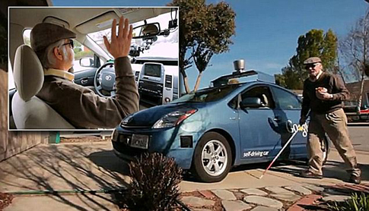
4: Steven Mahon - Blind Google Car Test Driver

Potential Benefits to Washington State

Short term (1-5 years)
The fiscal impact of changing permits to allow testing would be negligible.
Providing such permits creates the potential for significant investment by interested corporations.
Studies show that 37% of those surveyed would be interested in the technology at the present time.

Mid-term (5-15 years)
States with friendly legal climates can expect long-term corporate investment. (See Moses Lake.)
Car-sharing programs and programs for people with disabilities can be expanded, potentially reducing the load on accessibility providers.

Long term (>15 years)
If autonomous vehicles are widely adopted, there exists the potential for significantly reduced traffic and collisions, with large positive economic impact.
Users can work or relax while commuting or traveling, promoting productivity and health.
Environmental benefits will derive from high adoption because autonomous vehicles are likely to drive more efficiently, and possibly also due to platooning, (a mechanism whereby autonomous vehicles would communicate with one another wirelessly in order to safely drive at extremely close following distances, to draft at high speed).

Technical Challenges
  - What are the remaining technical obstacles to widespread adoption?
Citizens understandably anticipate a loss of personal autonomy if these vehicles are widely adopted. Foremost is the issue of safety: is it safe to cede control over one’s daily commute to a computer that must necessarily interact with unpredictable conditions and with other drivers? To address these concerns, engineers and lawmakers must address:
• Behavioral interfacing of autonomous vehicles with other cars on the road, particularly those human-driven, so that the ability to drive your own vehicle is not impeded, and so that driverless cars are safe for their occupants as well as for other users of the road.
• The potential friction between mass-transit advocates and a new type of personal automobile, by promoting the use of shared vehicles, high efficiency vehicles, and the continued use of mass transit in urban areas.
• The concerns of law enforcement, namely, the ability to redirect autonomous vehicles in emergency circumstances and the ability to safely perform a traffic stop, without impermissibly treading on privacy or civil rights, such as limits on search and seizure.

Legal Landscape in The United States

Current Status in Washington
Washington has already attempted to address this issue. Reps Hudgins (D-11), Buys (R-42), Upthegrove (D-33), Bergquist (D-11), Ryu (D-32), and Pollet (D-46) jointly introduced HB 1649 in the 2013 regular session. It is currently being reviewed in the House Committee on Transportation. The current bill principally allows testing of driverless vehicles on public roads before the development of official safety standards. The bill requires an attentive driver to operate the vehicle during the “testing phase” and places criminal and infraction liability solely on operator.

It is important to note that the current scope of HB 1649 only covers vehicles having “autonomous technology” which “renders it capable to drive without the active control or monitoring by a human operator,” but excludes other assistive technologies unless they enable operation without active control or monitoring by a human operator. The Washington proposed legislation ultimately charges the Washington State Patrol to develop safety standards for autonomous vehicles.

Current Law on Major Issues
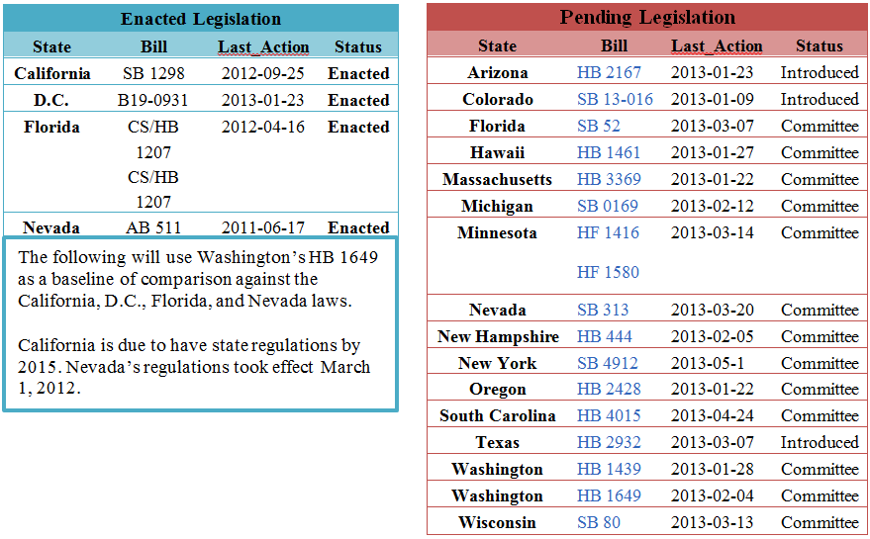

Definitions and Scope
All approaches, including Washington’s HB 1649, exclude all other assistive technologies which require an attentive driver to operate the vehicle. These approaches have near-identical language to HB 1649. As a result, all intermediary assistive technologies would be governed under existing traffic codes.

Furthermore, states that have addressed the issue of an unoccupied driverless vehicle, such as California and Florida, have defined “operator” of a driverless vehicle to include those who cause the vehicle to operate in driverless mode. As a result, this approach would place all rights and responsibilities on the person “causing the autonomous technology to engage” a driverless vehicle, until another person would either take control or cause the vehicle to operate in driverless mode. Washington, D.C. is silent on this particular issue.

Authority on Rules and Regulations
One aspect that sets HB 1649 apart from other approaches is that it requires the Washington Department of Licensing to work with Washington State Patrol in developing safety regulations, as opposed to merely suggesting collaboration. For instance, California charges its Department of Motor Vehicles to adopt safety standards by 2015, and adopt additional safety standards for operation without an operator in the driver’s seat of a driverless vehicle. Washington, D.C. places rulemaking authority in the Mayor’s Office.

Legislating the Testing Phase
All enacted legislation permits the testing of driverless vehicles on public roads. Every state also limits operation of driverless vehicles to manufacturer designees during testing. When an operator is not physically present in the vehicle during the testing phase, every state requires Special Approval During Testing. For instance, California and Florida require that autonomous vehicles be operated solely by designees of the manufacturer. California and Florida have also required any manufacturer to obtain at least $5 million in insurance coverage, and prohibits testing until the program is approved by California’s Department of Licensing.

Licensing and Permitting
Only Nevada, thus far, has required a separate license for the operation of an autonomous vehicle. All states have charged their respective agencies to require at least a valid operator’s license prior to operating a driverless vehicle, and require their respective departments to develop regulations. The Washington, D.C. law is the most ambitious, requiring the Mayor’s office to issue regulations by January 2014. California has charged its Department of Motor Vehicles to adopt additional safety standards for operation without an operator in the driver’s seat of a driverless vehicle.

Manual Override and Attentive Driver Issues
Almost every piece of legislation reviewed by The Clinic requires the technology to enable an operator to take control at a moment’s notice. This so-called “manual override” requirement bolsters the tie to personal liability in collisions and violations of the state traffic codes, outlined below. California and Florida even go so far as to specify technical requirements of driverless vehicles. However, the Nevada law requires the new license to anticipate that drivers will be operating the driverless vehicle while inattentive. This recognizes the full purpose of driverless vehicles, thereby legally enabling the operator to complete other tasks

Criminal and Infraction Liability
Nearly every approach reviewed places criminal and civil infraction liability on the operator of the vehicle. However, California’s SB 1298 is completely silent on the issue of liability, passing that responsibility onto its Department of Motor Vehicles to develop regulations by year 2015. Washington, D.C., and Florida’s laws provide an exemption to manufacturer liability when a vehicle is outfitted with driverless technology, allowing a case to be dismissed unless the defect was present prior to such an alteration. Washington, D.C. only allows conversions to vehicles of model year 2009 and later.

Civil Liability
California’s SB 1298 is completely silent on the issue of civil liability in accidents, passing the responsibility on to its Department of Motor Vehicles to develop regulations by 2015. Florida and DC both apply a manufacturer liability exemption provision to civil suits.

Other Unique Issues
California requires manufacturers to disclose to purchasers the kind of information collected by driverless vehicles, but no other enacted approach contains a comparable provision. Interestingly, Nevada lumped its driverless car bill with low emissions automobile, and high-occupancy vehicle legislation.

Conclusion on Varying State Approaches
Every state with enacted legislation has largely borrowed from each other. Issues relating to the physical presence of the driver, testing, and scope of the law are nearly identical. All states require some form of manual override, with varying degrees of specific requirements for the technology.

States have largely ignored the liability issue thus far, passing the responsibility on to their respective licensing agencies. This is likely intended to allow insurance companies to submit comments on the liability issues when agencies initiate the rulemaking processes.

Preemption
  - What international standards or federal laws already exist in this space?

Express preemption
The National Traffic and Motor Vehicle Safety Act (NTMVSA), passed by Congress in 1966, sets out the framework for federal vehicle safety regulation. It empowered the National Highway Traffic Safety Administration (NHTSA) to regulate vehicle safety measures and device requirements and was intended to allow for a uniform system of safety regulation that manufacturers could rely on when designing vehicles. The Act, codified at 49 U.S.C. §30101 et seq., includes a preemption provision that governs courts’ analysis of whether a state law is expressly preempted by the Act or NHTSA regulations. However, neither the NTMVSA nor the NHTSA regulations currently speak to autonomous vehicles.

Despite this silence, it is possible that certain elements unique to autonomous vehicles could be considered to fall within categories or definitions that are currently regulated pursuant to the NTMVSA. If a state attempts to regulate an aspect of vehicle performance that is already covered by the NTMVSA or NHTSA regulations, it will be expressly preempted. In theory, many aspects of autonomous vehicle design could be construed as relating to “aspects of performance” governed by the NHTSA regulations. The Second Circuit narrowly construed the regulations, but other courts may construe those or other regulations more broadly, depending on the language used. It is wise to check carefully for any possible construction under which the state regulation would be preempted.

Notably, a state can require safety standards greater than those required by the NTMVSA and its attendant regulations for vehicles “obtained for its own use.” This is important, because even if the NHTSA does regulate autonomous vehicle safety requirements, a state could purchase autonomous vehicles for its own use and then require them to meet more strenuous standards. This would be useful if a state wanted to develop a pilot program featuring state-owned vehicles.

Traffic control devices like roadway signage and traffic lights are subject to express federal regulation. State law altering the use of any traffic control devices mentioned in the federal regulation would be preempted, but use of traffic control devices not mentioned may be allowed. If a state feels it wise to introduce assistive devices of some sort for autonomous vehicles, there may be some room to add them unless the Federal Highway Administration (FHWA) weighs in on the matter.

Implied preemption
When a federal statute does not expressly preempt particular states laws, those laws may still be preempted by implication from other acts of Congress. If Congress has indicated its intent to occupy an entire field, any state laws within that field are preempted. Similarly, if a state law would frustrate the purpose or effectively require noncompliance with a federal law, such a state law would also be preempted by the conflict.

Field preemption
There is no issue with field preemption related to vehicle safety regulations. Courts will presume that the federal government does not occupy the field when that field is one of traditional state activity pursuant to the states’ police powers, and motor vehicle safety is one such field. Although Congress has acted in the field of vehicle safety via the NTMVSA to regulate vehicle safety, that act included a savings clause that creates a continued role for the common law of, e.g., product liability. Thus, Congress appears not to have intended to occupy the entire field of vehicle safety law. Still, some defendants have argued that the field should be conceived of more narrowly in particular cases, and it is at least plausible that a court might conceive of the NTMVSA as occupying a field of vehicle safety measure regulation.

Highway safety regulations, if conceived of differently than vehicle safety regulations—which at least court one circuit court has notably decided do not—are similarly protected from claims of field preemption by the presumption in favor of traditional state powers. A state law regulating highway traffic will not be preempted unless Congress has clearly intended preemption. Absent a conflict preemption issue, no implied preemption will be found.

Other traditional state regulatory efforts will similarly not be preempted by federal law. Liability for negligent operation of a vehicle has not been preempted by Congressional legislation, and states have traditionally exercised their police powers in the form of tort law. The presumption against preemption therefore applies. State licensing of vehicle operators is another area of historical state control. The federal Real ID Act has likely preempted the field of driver’s license document standards and possibly data collection and verification requirements associated with driver’s license applications, but the granting of licenses and setting of relevant standards for those grants remains an area of state power.

B. Conflict preemption
Although the savings clause in the NTMVSA has been held to negate claims of field preemption, implied preemption of state vehicle safety laws is still possible. If a state vehicle safety regulation actually conflicts with the regulatory structure established by the NTMVSA, the state law is preempted by implication. Although the NTMVSA’s savings clause created room for common law liability, and thus the NTMVSA did not occupy the field of vehicle safety law, any direct conflict between the common law and federal regulation pursuant to the NTMVSA would be resolved in favor of the regulation. Any state seeking to promulgate laws or regulations regarding the use of autonomous vehicles therefore needs to be sure that its actions will not conflict with the federal vehicle safety regulatory scheme.

Currently, federal regulations are silent on the issue of autonomous vehicles, likely because the technology is still quite new and has not been adopted beyond testing activities. Such silence will not be interpreted to preempt state law in the absence of a “clear and manifest purpose.” However, any state that intends to require particular safety features will need to investigate whether requiring those features can be construed to conflict with any other federal regulatory requirements.

Legislative Role
The Legislature should implement a legal regime that defines driverless cars and their regulation that is compatible with the consensus legislation among the states. If Washington follows California, Nevada and Florida in permitting early testing, that policy may but will not necessarily accelerate adoption and investment.

Future legislation will be necessary, but will depend in part on the results of the testing period, and in particular on the rulemakings of the NHTSA, and possibly those states which are early adopters. Notably, if the Washington State Legislature does not move quickly on the entire subject of autonomous vehicles, it is suggested that the legislators of this state consider early on those issues which may arise during testing and initial introduction of this technology.

About the Authors

James Barker (Introduction, Technical State of the Art)
Juris Doctorate candidate; Class of 2014

James received his BS in Mechanical Engineering from Johns Hopkins University in 2007 and his MS from the University of Washington in 2009. His professional background is in renewable energy research, and his legal interests are primarily in patent law on renewable energy technology. He can be reached at JPB9@uw.edu

Sam Mendez (Impact on Individuals, Washington State)
Juris Doctorate candidate; Class of 2014

Sam received his BA from University of California, Santa Cruz and spent time in Portland working at an energy efficiency non-profit before starting law school. Sam has strong interests in emerging technologies, IP, and related policy. He will work this summer at the Senate Committee Services in Olympia. Sam can be reached at smendez@gmail.com.

Evan Brown (Preemption)
Juris Doctorate candidate; Class of 2014

Evan Brown received his BA in History and Philosophy from Pitzer College. Prior to law school he worked as an editor in the geography and international studies group at ABC-CLIO. His policy interests include data infrastructure, Internet regulation, and technology development policy. Evan can be reach at eatb@uw.edu

Tim Billick (Legal Landscape in the United States)
Juris Doctorate conferred; Class of 2013

Tim graduated from Purdue University with a BS in Business Management, with a concentration in Philosophy in 2010. Before law school, Tim also drafted changes to the Violence Against Women Act and led a team of domestic violence victims to Washington, D.C. to propose these changes to U.S. Representatives and Senators. Tim is also writing an article about California's cap & trade program, and he blogs about other legal issues surrounding the internet. Tim can be reached at tbillick@gmail.com

Justin Glick (Current Law on Major Issues)
Juris Doctorate conferred; Class of 2013

Justin received his BA from Northwestern University and spent several years before law school writing about urban development policy. During law school, he served as a Legal Fellow to U.S. Senator Patty Murray, focusing on tax and trade policy. He is interested in clean energy financing and related policy areas. Justin can be reached at jsglick@uw.edu.

Contact
This white paper was drafted by the Autonomous Vehicles Team of the University of Washington School of Law, Clinic on Technology, Law and Public Policy, under the supervision of Professor William Covington

Please contact the clinic through William Covington
Director, Technology Law & Public Policy Clinic
Assistant Professor of Law
Phone: (206) 616-4481
Email: covinw@uw.edu

http://iedeiblog.com/2012/06/24/driverless-car-and-futuristic-roads/
http://sciencegravity.blogspot.com/2012/10/google-driverless-car.html
http://www.driverless-future.com/?p=378
http://www.bmw.com/com/en/newvehicles/3series/sedan/2011/showroom/safety/active_protection.html#t=l
http://www.mbusa.com/mercedes/benz/safety#module-4
http://www.nbcnews.com/technology/students-self-driving-car-tech-wins-intel-science-fair-1C9977186
http://www.f1fanatic.co.uk/2009/11/29/audi-builds-driver-less-car-for-pikes-peak/
http://www.roadandtrack.com/go/first-looks/new-car-tech-2014-mercedes-benz-s-class
http://www.businessinsider.com/2014-bmw-i3-moves-us-closer-to-autonomous-driving-in-cities-2011-8
http://blogs.wsj.com/drivers-seat/2012/12/03/volvo-plans-to-roll-out-self-driving-cars-in-2014/
http://www.pcworld.com/article/254192/cadillac_self_driving_cars_out_by_2015_.html
http://news.drive.com.au/drive/motor-news/driverless-cars-possible-by-2015-20130313-2fz96.html
http://www.engadget.com/2012/10/03/nissan-nsc-2015-self-driving-car-with-lte-and-smartphone-connect/
http://www.techradar.com/us/news/car-tech/google-wants-some-form-of-self-driving-cars-on-roads-by-2018-1130660
http://wot.motortrend.com/volvo-autonomous-car-convoys-could-be-reality-2020-80731.html
http://www.forbes.com/sites/danbigman/2013/01/14/driverless-cars-coming-to-showrooms-by-2020-says-nissan-ceo-carlos-ghosn/
http://elitedaily.com/elite/2012/googles-selfdriving-car-blind-wheel/
http://reviews.cnet.com/8301-13746_7-57422698-48/many-car-buyers-show-interest-in-autonomous-car-tech/
http://www.bizjournals.com/seattle/news/2013/04/17/bmwsgl-plant-in-grant-county-readies.html
HB 1649, see http://apps.leg.wa.gov/documents/billdocs/2013-14/Pdf/Bills/House%20Bills/1649.pdf
Information last updated May 19, 2013. For latest information, see http://apps.leg.wa.gov/billinfo/summary.aspx?bill=1649&year=2013#history
“…electronic blind spot assistance, crash avoidance, emergency braking, parking assistance, adaptive cruise control, lane keep assistance, lane departure warning, or traffic jam and queuing assistance.”
This mandate, however, only relates to suggesting to the Legislature when “large scale production” of these vehicles appears imminent. See HB 1649 § 6(1).
California SB 1298, http://www.leginfo.ca.gov/pub/11-12/bill/sen/sb_1251-1300/sb_1298_bill_20120925_chaptered.html
DC Bill http://dcclims1.dccouncil.us/images/00001/20130110191554.pdf
California SB 1298(b)(1), http://www.leginfo.ca.gov/pub/11-12/bill/sen/sb_1251-1300/sb_1298_bill_20120925_chaptered.html
DC Bill http://dcclims1.dccouncil.us/images/00001/20130110191554.pdf
California SB 1298, http://www.leginfo.ca.gov/pub/11-12/bill/sen/sb_1251-1300/sb_1298_bill_20120925_chaptered.html
See Cal. Code §38750(d) et seq, available at http://www.leginfo.ca.gov/cgi-bin/displaycode?section=veh&group=38001-39000&file=38750; Fl. Code § 319.45(1) available at http://www.flsenate.gov/Session/Bill/2012/1207/BillText/er/PDF;
Florida Bill http://www.flsenate.gov/Session/Bill/2012/1207/BillText/er/PDF; DC Bill http://dcclims1.dccouncil.us/images/00001/20130110191554.pdf
DC Bill, http://dcclims1.dccouncil.us/images/00001/20130110191554.pdf
Florida Bill, http://www.flsenate.gov/Session/Bill/2012/1207/BillText/er/PDF
California SB 1298, http://www.leginfo.ca.gov/pub/11-12/bill/sen/sb_1251-1300/sb_1298_bill_20120925_chaptered.html
AB 511 http://www.leg.state.nv.us/Session/76th2011/Bills/AB/AB511_EN.pdf
The relevant language provides that “[w]hen a motor vehicle safety standard is in effect under this chapter, a State or a political subdivision of a State may prescribe or continue in effect a standard applicable to the same aspect of performance of a motor vehicle or motor vehicle equipment only if the standard is identical to the standard prescribed under this chapter.” 49 U.S.C. §30103(b).
The aspects of vehicle performance addressed by the NTMVSA include tire performance, 49 U.S.C. §30123; rollover prevention and crash mitigation, §30128; bumper sufficiency, ch. 325; fuel economy, ch. 329; and theft prevention systems, ch. 331. NHTSA regulations currently extend to safety equipment; crash avoidance systems like brakes, mirrors, seats, and restraints; and impact mitigation designs.
Chrysler v. Tofany ,419 F.2d 499, 511 (2d Cir. 1969) (holding that state laws granting state commissioners the power to deny drivers the ability to add an external automobile light were not preempted by NHTSA regulations on external lighting).
See Manual on Uniform Traffic Control Devices for Streets and Highways, http://mutcd.fhwa.dot.gov.
23 CFR 655.603(a).
See, e.g., Cipollone v. Liggett Grp., Inc., 505 U.S. 504, 516, 112 S. Ct. 2608, 120 L. Ed. 2d 407 (1992).
See, e.g., Fidelity Fed. Sav. & Loan Assn. v. De la Cuesta, 458 U.S. 141, 153, 102 S.Ct. 3014, 3022, 73 L.Ed.2d 664 (1982).
See, e.g., Pacific Gas & Elec. Co. v. State Energy Resources Conservation and Development Comm'n, 461 U.S. 190, 204, 103 S.Ct. 1713, 1722, 75 L.Ed.2d 752 (1983).
City of Columbus v. Ours Garage and Wrecker Serv., 536 U.S. 424; Medtronic v. Lohr, 518 U.S. 470; Chamberlain v. Ford, 314 F.Supp.2d 953.
Ours Garage, 536 U.S. at 439.
49 U.S.C. § 30101.
49 U.S.C. § 30103(e). see also Wood v. Gen. Motors Corp., 865 F.2d 395 (1st Cir. 1988). The legislative history is also fairly clear on this point. See Wood, 865 F.2d at 416.
Chamberlain, 314 F. Supp. 2d at 958.
See Raymond Motor Transp., Inc. v. Rice, 434 U.S. 429, 443, 98 S. Ct. 787, 54 L. Ed. 2d 664 (1978) (“In no field has this deference to state regulation been greater than that of highway safety regulation.”); Bibb v. Navajo Freight Lines, Inc., 359 U.S. 520, 523–524, 79 S. Ct. 962, 3 L. Ed. 2d 1003 (1959) (noting that highway safety laws are “peculiarly local” and “carry a strong presumption of validity”).
See Cipollone, 505 U.S. at 518.
See Geier v. Am. Honda Motor Co., Inc., 529 U.S. 861, 120 S. Ct. 1913, 146 L. Ed. 2d 914 (2000) (holding that a product liability law could not be applied to create liability for an automobile manufacturer’s decision not to include airbags in its cars when federal regulations were intended not to require airbags).
Ketchum v. Hyundai Motor Co., 49 Cal. App. 4th 1672, 1675, 57 Cal. Rptr. 2d 595 (1996); see also Chrysler Corp. v. Rhodes, 294 F. Supp. 665, 666 (D.N.H. 1968) aff'd, 416 F.2d 319 (1st Cir. 1969).

