WASHINGTON STATE HOUSING FINANCE COMMISSION

Qualified energy Conservation Bond PROGRAM
Application

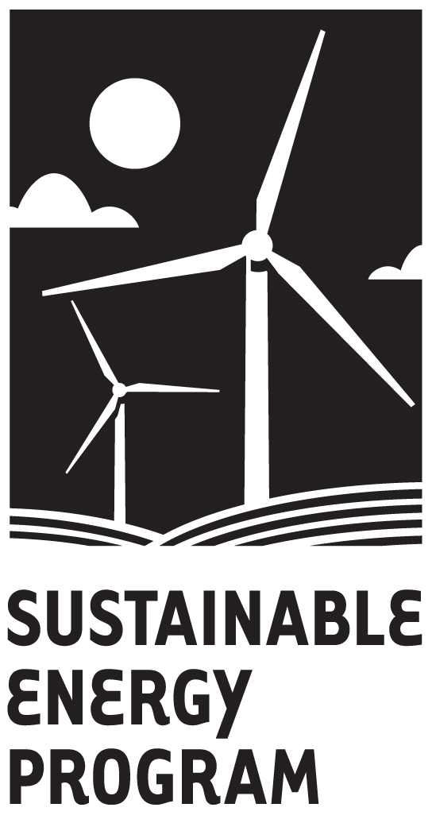

Please complete all sections of this application.
Questions? Contact Multifamily Housing and Community Facilities staff at (800) 767-4663

Borrower
  - Organization/Borrower Name:
  - Address:
  - City: State: Zip:
  - Telephone: Fax:
  - Contact Person: Title:
  - Email Address :
  - Address (if different):
  - Telephone (if different): Fax (if different):
Please note that organizational and project information is subject to public records requests.
- Project Site Information
  - Project Name:
  - What is the Purpose of the Project / Financing?
  - Street Address:
City: County: Zip:
  - Congressional District: State Legislative District:
  - If site address is not available, give a brief description of all properties.
(Attach extra sheets if necessary)_________________________________________________
Commission use only
OID #

Date approved:
____________________________________
____________________________________
____________________________________
- Organizational and General Project Information
  - Is your organization affiliated with, or related to, any other organization?
□ YES Name of organization
Nature of relationship
□ NO
  - Has your organization, or an affiliate, used tax-exempt or tax credit bonds?
□ YES What is the aggregate amount of bonds outstanding?
________________________________________________
□ NO
  - Has your board formally committed to developing this project?
□ YES (Please attach a copy of the resolution or approved Board minutes.)
□ NO

If the project is affordable housing, does it currently have a regulatory agreement in effect?
□ YES Expiration date:
□ NO

Project Information
  - Does your facility include a residential component?
□ YES
  - NO
  - Will your facility serve as a house of worship or be used by a religious organization?
□ YES (Contact Multifamily Housing and Community Facilities Staff)
  - NO
  - If the facility is a school, does it have a religious affiliation?
□ YES (A separate “pervasively sectarian” review will be required)
  - NO

  - Check the category or categories into which your project fits (per QECB legislation).

Capital expenditures incurred for purposes of (indicate one):
Reducing energy consumption in publicly-owned buildings by at least 20 percent.
Implementing green community programs.
Rural development involving the production of electricity from renewable energy resources.
Any qualified facility (as determined under section 45(d) without regard to paragraphs (8) and (10) thereof and without regard to any placed in service date).
Describe:
Expenditures with respect to research facilities, and research grants, to support research in (indicate one or more):
Development of cellulosic ethanol or other non-fossil fuels.
Technologies for the capture and sequestration of carbon dioxide produced through the use of fossil fuels.
Increasing the efficiency of existing technologies for producing non-fossil fuels.
Automobile battery technologies and other technologies to reduce fossil fuel consumption in transportation.
Mass commuting facilities and related facilities that reduce the consumption of energy, including expenditures to reduce pollution from vehicles used for mass commuting.
Demonstration projects designed to promote the commercialization of (check one or more):
Green building technology.
Conversion of agricultural waste for use in the production of fuel or otherwise.
Advanced battery manufacturing technologies.
Technologies to reduce peak use of electricity.
Technologies for the capture and sequestration of carbon dioxide emitted from combusting fossil fuels in order to produce electricity.
Public education campaigns to promote energy efficiency.

  - If there is the land associated with the facility, is the land:
□ Owned
  - Leased (Please attach a description of the terms and conditions of the lease, including lessor information, and indicate whether the lessor is a government entity, 501(c)(3) nonprofit, or other entity.)
  - To Be Purchased (Please contact the Commission.)
  - What is the approximate land area?
  - Will all of the land be exclusively used by your organization for project purposes?
□ YES
□ NO (Please attach a sheet describing “other” use, including descriptions of the organizations involved and copies of any lease agreements.)
  - Number of buildings:
    - If more than one building, are they located on the same tract of land (same address)?
□ YES
□ NO (Please attach a description of the tracts and buildings.)
    - What is the approximate building square footage? (If more than one building, please describe each.)
  - Will this project be part of a Green Communities Program?
□ YES (Please attach copy of signed Green Community Program Participation Letter)
□ NO
  - Please describe your public outreach plan (attach extra sheets if needed):
_______________________________________________________________
_______________________________________________________________
  - Please provide a narrative description of the project (attach extra sheets if needed).

- Project Financial Information
The Commission will use the chart below to better advise you on our programs. If you are unsure as to how much money you will spend or what sources of money you will use to complete your project, please ask us for assistance in completing this section.
Purpose | Bond/Loan Uses | Applicant  Contribution | Other Financing | Total
TOTAL

- Timing
- When do you expect to close the financing? __________________
- Are there permits required?
□ YES Date permits expected? ______________________
  - NO
- Lender Information
- Which lender(s) are you working with? __________________
- Which vender(s) are you working with? __________________
VIII. ESTIMATED EMPLOYMENT IMPACT OF PROJECT
  - Current number of employees at the site/on the project:

B. Additional employment figures:

Number of new jobs created by project
Current employees retained due to project
Construction-related jobs created

C. Will this project provide jobs for lower income persons from the community?

- Are you planning to hire through the local Department of Employment Security Job Service Center

Yes
No.

CHECKLIST
Please include the following attachments to the application if requested:
  - II.B Narrative description of project
  - II.F Complete Property Location Descriptions
  - III.C Board Minutes / Resolution
  - IV.E Equipment to be financed with bond proceeds
  - IV.F Copies of Leases or Purchase & Sale Agreement
  - IV.H Description of “other” uses of land
  - IV.J Description of project on multiple tracts of land
  - IV.M Description of facility management by outside entity
  - IV.N Description of use unrelated to conservation purpose
  - IV.O Description of facilities used by other organizations
  - V.D Description of equipment or “other” purposes of debt to be refinanced
  - VII.C Community, SEPA, or other permit/review processes and timing

Application Fee
- $400 for bond issues up to $1.5 million
- For bond issues above $1.5 million, the fee is $400 plus .03% of the amount above $1.5 million to a cap of $5,000.
Application Fee Example Table:
Bond Amount | Base Fee | Amount Above $1.5M | Rate | Calculation | Total Fee = Base Fee +  Calculation Up to $5,000
$1,400,000 | $400 | $0 | 0.0003 | $0 | $400
$1,700,000 | $400 | $200,000 | 0.0003 | $60 | $460
$2,500,000 | $400 | $1,000,000 | 0.0003 | $300 | $700
$7,500,000 | $400 | $6,000,000 | 0.0003 | $1,800 | $2,200
$12,500,000 | $400 | $11,000,000 | 0.0003 | $3,300 | $3,700
$16,500,000 | $400 | $15,000,000 | 0.0003 | $4,500 | $4,900
$17,500,000 | $400 | $16,000,000 | 0.0003 | $4,800 | $5,000

Attached is a non-refundable application fee in the amount of
$ Application Fee

APPLICANT

TITLE

ORGANIZATION

DATE
Please mail this application to: 
Attn: Multifamily Housing and Community Facilities
Washington State Housing Finance Commission
1000 Second Avenue, Suite 2700
Seattle, WA 98104-1046

