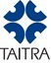
Sourcing Taiwan for Government Procurement
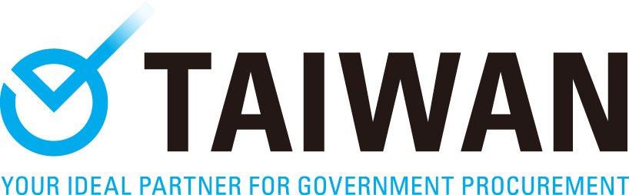
-Oct. 2018-
Application Form
All fields are required and must be completed to process the application.
Company Information
Company |  | Year Established
City/Country
E-mail |  | Tel.
Annual Sales | US $ | No. of Employees
URL
Nature of your PROFESSION/TYPE OF ORGANIZATION. (Please check all that apply)
□ Government □ Group
□ Engineering Consultancy □ Engineering & Construction
□ Land development □ Financial institution for ODA
□ Organization to promote ODA business
□ System Integrator Service Provider(pls.specify: )
Company Profile: (Describe your company, products, solutions, or services in a short paragraph)
(若該公司在當地市場具有一定特色或佔比，請務必指出，以讓參展廠商瞭解；另請陳述其最常承接哪個政府部門之專案，以讓本專案瞭解其人脈關係)

Attendee Information
Attendee’s Name | Title / Dep. | E-mail | Mobile Phone
□ Ms. □ Mr.
_____________________
Have you ever received any incentives from TAITRA in the past?
(E.g. free air ticket and/or hotel accommodation)
□ Yes When： What event:
□ No
- Will the attendee be accompanied:
□ No
□ Yes (Travel expenses should be covered by the accompanied.)
- Dietary requirements:
- Vegetarian
- Muslim
- Other (pls.specify: )

Sourcing Information
Sourced Solution/Service |  | Solution Descriptions (please be detailed) | Approx. Purchasing Amount (US$)
1.
2.
3.
4.
5.
6.
Current Partners/Vendors in Taiwan: (If none, please leave this field blank.)
The names /types of companies you would like to meet at the 1-on-1 Meeting on Oct. 9th?
□No
□Yes (pls specify: )
Any Taiwan successful performance you are interested to pay a visit on Oct. 8th?
□ No
□ Yes, I am interested in as following: (Please check all that apply)
(The itinerary arrangement is subject to TAITRA.)
Field | Specify
- Transport
Field | Specify
- Water
- Waste
- Green Energy
- Healthcare
- Others
Additional Comments: (If nothing is to be expressed, please leave this field blank.)

